**Moderate to Severe Evaluation**

Sample_id : **XFYVPJ(Cat)**

Link:<https://release.animalbiome.com/pet/assessment/report/summary/af978698-a5a1-4ec3-8d06-f3903a929228>

Cats and dogs:

Any two of the following:

(

High Red Flag Megamonas OR (**passed**)

High Red Flag Sutterella OR (failed)

High Red Flag Collinsella OR (failed)

Low Red Flag Bacteroides OR (**passed**)

Low Red Flag Blautia (failed)

);

OR

Cats:

11 or more yellow flags;(failed)

OR 9 or more red flags;(failed)

High red suttrella and collinsella failed.

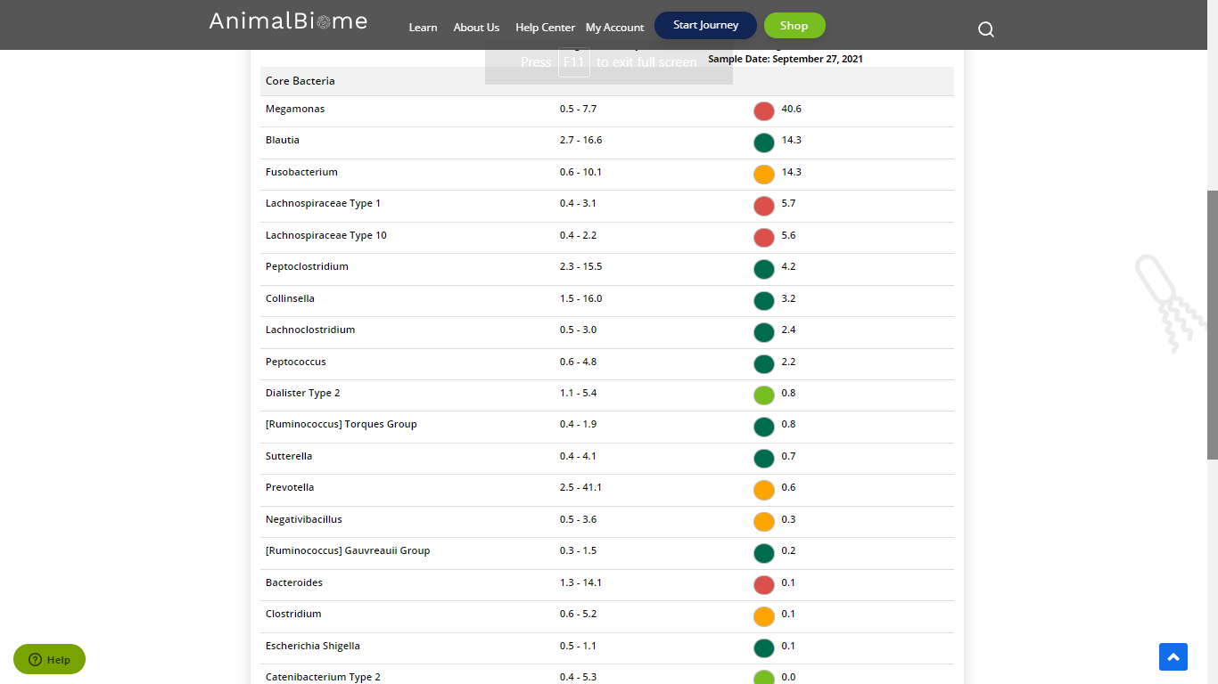



low red blautia : failed

Low red bacteroides : passed (two conditions satisfied ) in the primary group.

Total yellow flags : 5

Red flags : 6

The result : **True False False**

Moderate to severe results:Pass

Expected result :  **Moderate to severe**

Achieved result : **passed.**

